**Experiment 5**

**Interfacing Temperature and Humidity Sensor with Arduino in Tinkercad**

**AIM:**

To interface a temperature and humidity sensor with an Arduino board using Tinkercad and display the sensor readings.

**COMPONENTS REQUIRED:**

1. Arduino Uno
2. DHT11 or DHT22 Temperature and Humidity Sensor
3. Resistor (10kΩ) – if required
4. Breadboard
5. Jumper wires

**THEORY:**

The DHT11/DHT22 sensor measures temperature and humidity using a capacitive humidity sensor and a thermistor. It sends the data digitally to the Arduino through a single data pin. The Arduino processes the signal and displays the values on the serial monitor.

**STEPS FOR TINKERCAD:**

1. Open [Tinkercad](https://www.tinkercad.com/) and sign in.
2. Create a new circuit and search for "Arduino Uno" in components.
3. Add the DHT11/DHT22 sensor to the circuit.
4. Connect the **VCC** pin of the sensor to the **5V** pin of the Arduino.
5. Connect the **GND** pin of the sensor to the **GND** pin of the Arduino.
6. Connect the **Data** pin of the sensor to **Digital Pin 2** of the Arduino.
7. (Optional) Place a **10kΩ pull-up resistor** between the **VCC** and **Data** pin.
8. Click on "Start Simulation" to run the circuit.
9. Open the Serial Monitor to view temperature and humidity values.

**Connection Diagram**

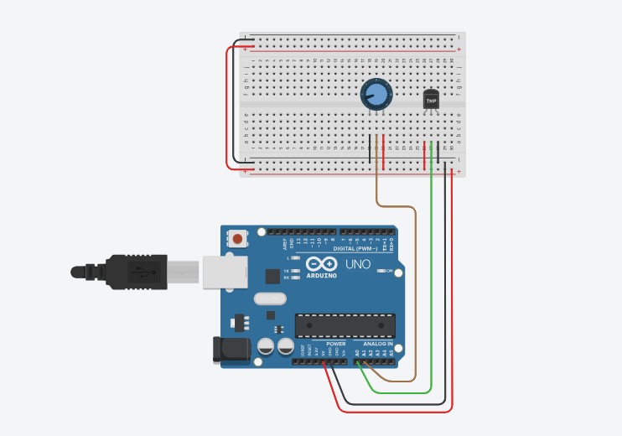

**Code:**

const int analogIn = A0;

int humiditysensorOutput = 0;

// Defining Variables

int RawValue= 0;

double Voltage = 0;

double tempC = 0;

double tempF = 0;

void setup(){

Serial.begin(9600);

pinMode(A1, INPUT);

}

void loop(){

RawValue = analogRead(analogIn);

Voltage = (RawValue / 1023.0) * 5000; // 5000 to get millivots.

tempC = (Voltage-500) * 0.1; // 500 is the offset

tempF = (tempC * 1.8) + 32; // convert to F

Serial.print("Raw Value = " );

Serial.print(RawValue);

Serial.print("\t milli volts = ");

Serial.print(Voltage,0); //

Serial.print("\t Temperature in C = ");

Serial.print(tempC,1);

Serial.print("\t Temperature in F = ");

Serial.println(tempF,1);

humiditysensorOutput = analogRead(A1);

Serial.print("Humidity: "); // Printing out Humidity Percentage

Serial.print(map(humiditysensorOutput, 0, 1023, 10, 70));

Serial.println("%");

delay(5000); //iterate every 5 seconds

}

**OUTPUT:**

**RESULT:**

The temperature and humidity values will be displayed in the Serial Monitor, confirming successful interfacing of the DHT sensor with Arduino in Tinkercad.